|  |  |
| --- | --- |
| **Subject** | Science |
| **Course** | Botany |
| **Grade** | HS |
| **Standard** | BOT.1.6 |
| **Standard Description** | Demonstrate through model development and manipulation an understanding of plant biochemistry. |
| **Lesson Name** | Plant Biochemistry |

**Lesson Outcome:** Students will be able to understand the key biochemical processes involved in plant metabolism such as photosynthesis, and respiration. Students will be able to analyze the importance of photosystems, light pigments, the functioning of the electron transport chain, ATP synthesis, exploring the importance of different plant hormones.

**Learning Objectives:**

At the end of the lesson, you will be able to do the following:

* Explain and analyze a model depicting key biochemical processes of photosynthesis, and respiration emphasizing their significance in plant growth and energy production.

**Text popper question**: What is the main function of a cell wall in plants?

Text popper image

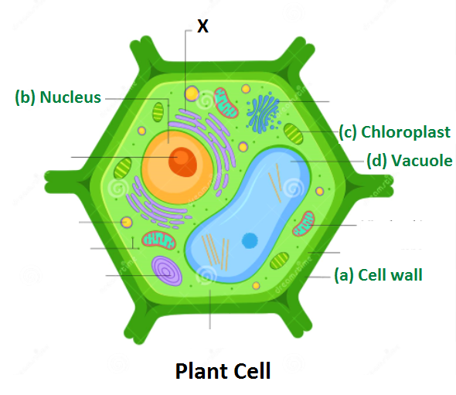

<https://www.embibe.com/questions/Draw-a-typical-plant-cell-and-label-the-following-parts--%28a%29-Cell-wall-%28b%29-Nucleus-%28c%29-Chloroplast-%28d%29-Vacuole./EM7120695>

Note:-Create a similar image

* Describe the role of light energy and pigments in photosynthesis, the functioning of photosystems I and II, the electron transport chain, and ATP synthesis.

**Text popper question:** In alcoholic fermentation, glucose gets converted into which substance?

Text popper image

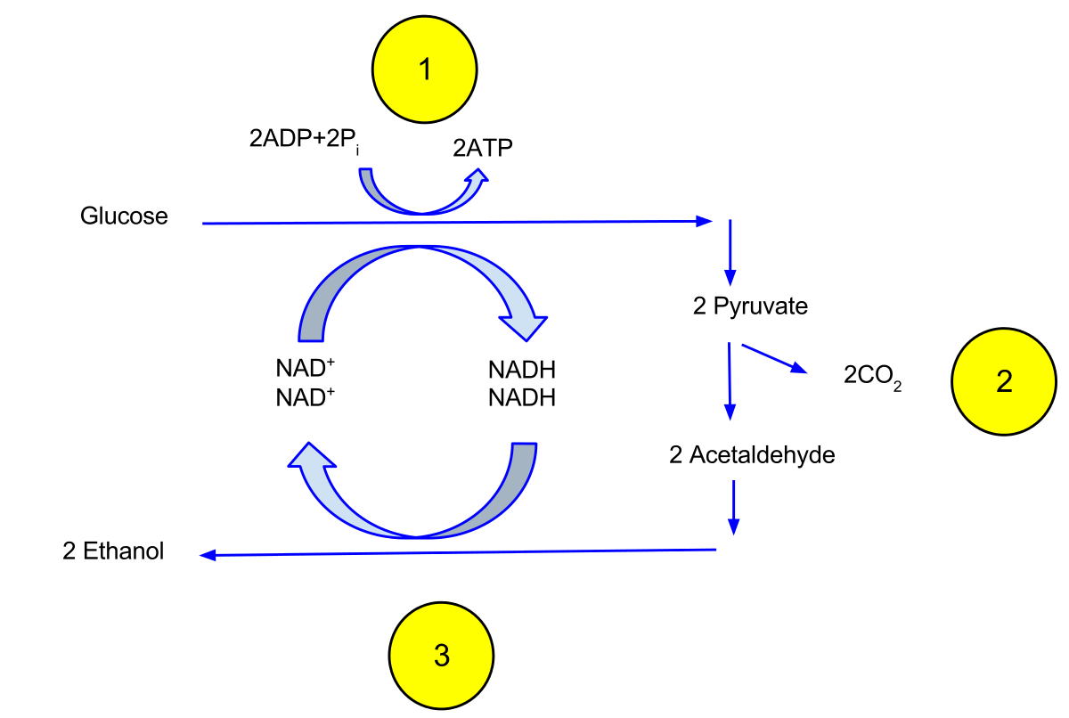

<https://en.wikipedia.org/wiki/Ethanol_fermentation>  
Note:-Create a similar image

* Summarize the significance of carbohydrates as an energy source in plants, including their synthesis, degradation, and the enzymes involved.

**Text popper question:** What enzyme is responsible for catalyzing and the transfer of glucose molecules from ADP-glucose to the growing starch chain in plants?

Text popper image

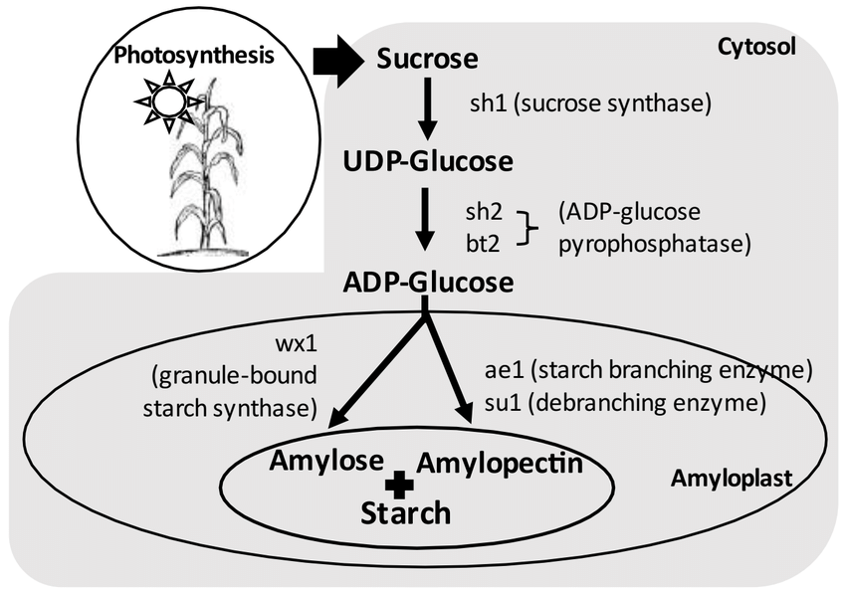

<https://www.researchgate.net/figure/Diagram-of-starch-biosynthesis-pathway_fig3_357401789>

Note:-Create a similar image

* Explore different types of plant hormones, their roles in growth, and their functions.

**Text popper question:** What is the main function of Cytokines in plants?

Text popper image

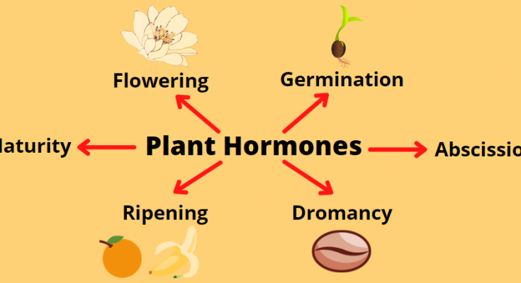

[**https://classnotes123.com/what-are-plant-hormones-class-10/**](https://classnotes123.com/what-are-plant-hormones-class-10/)

Note:-Create a similar image

## **Introduction to Plant Biochemistry**

Plant biochemistry is the study that involves studying chemical processes and molecular mechanisms in plants. It attempts to study the processes behind plant growth and development.

Understanding plant biochemistry helps in determining what factors play a role in plant physiology and how plants synthesize nutrients, produce energy, respond to stress, and interact with their surroundings.

This knowledge of plants helps us in developing new technologies related to plant growth, developing agricultural strategies, and improving crop productivity.

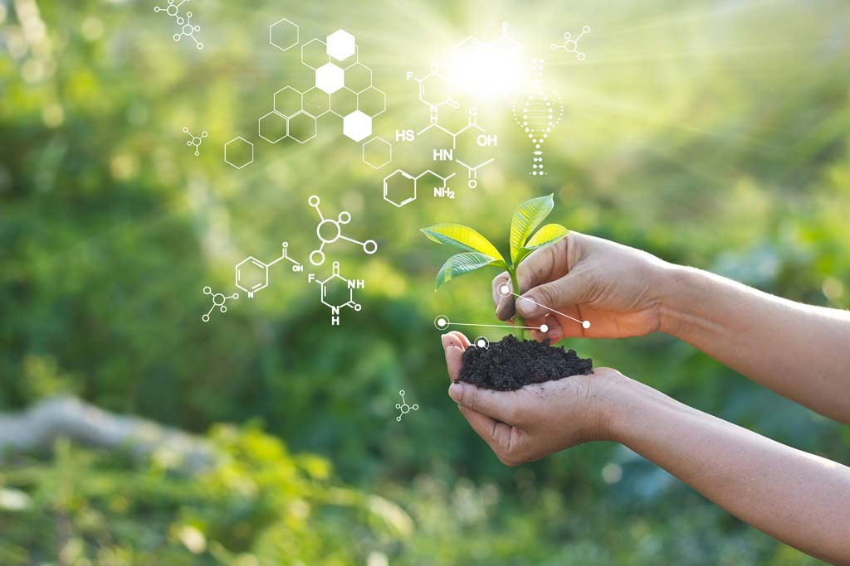

<https://www.acs.edu.au/courses/biochemistry-i-plants-200.aspx>

Note:-Create a similar image

### **Plant Cellular Structure and Organization Overview**

Plants have an organized cellular structure that supports their essential functions. Plants are composed of different cellular components each has its own functions.

**Cell Wall -** Plants have a thick cell wall that protects from external damage, and provides support and protection to the cell.

It allows cells to have a definite shape and structure.

**Cell Membrane -**The cell membrane also called as plasma membrane, regulates and controls the transport of material inside the cell. It maintains the gradient required.

**Nucleus -** The nucleus is the central control center that contains the genetic part of the plant including DNA. It regulates cell activities and controls the production of proteins.

**Chloroplasts -** Chloroplasts are responsible for photosynthesis, the process by which plants convert sunlight, water, and carbon dioxide into glucose and oxygen. They contain chlorophyll, a pigment that captures light energy.

**Mitochondria -** Mitochondria are the powerhouses of the cell. They generate energy through cellular respiration, which fuels other cell processes is very important for cell growth.

**Endoplasmic Reticulum (ER)** - The endoplasmic reticulum is a network of membranous tubes and sacs involved in protein synthesis, and lipid metabolism.

**Vacuole -** These are large fluid-filled sacs for storing water, ions, and nutrients. They maintain cell turgidity and regulate cell volume.

Understanding the cellular structure of plants and their organization is crucial for studying plant development and growth.

The image below depicts all the cellular components of a plant.



<https://www.embibe.com/questions/Draw-a-typical-plant-cell-and-label-the-following-parts--%28a%29-Cell-wall-%28b%29-Nucleus-%28c%29-Chloroplast-%28d%29-Vacuole./EM7120695>

Note:-Create a similar image

**Quick Check: The cell membrane regulates the transport of material inside the cell. Is it true or false?**

Answer: It is true.

Explanation: The cell membrane act as a barrier to control the entry and exit of the cell material.

**Plant Cell Metabolism**

**Photosynthesis**

Photosynthesis is a vital biochemical process in plants, algae, and some bacteria. It is the process by which plants convert sunlight, carbon dioxide, and water into a form of sugar- glucose, and oxygen.

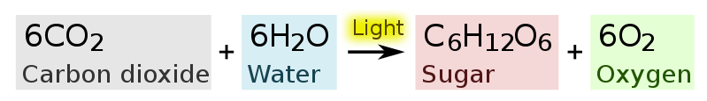

<https://upload.wikimedia.org/wikipedia/commons/thumb/f/fd/Photosynthesis_equation.svg/799px-Photosynthesis_equation.svg.png?20100526031449>

Note:-Create a similar image

### **Importance of Photosynthesis**

The process of photosynthesis serves as a primary source of energy for most ecosystems on Earth, as it provides the base for the food chains that sustain life.

Moreover, the glucose produced via photosynthesis serves as a building block for plant growth. In essence, photosynthesis is a very important fundamental process that drives plant cell metabolism.

**Quick Check: Photosynthesis is a fundamental process which drives the plant metabolism. Is it true or false?**

Answer- It is true.

Explanation- Photosynthesis powers plant metabolism, aids in energy production which help in plant’s growth and development.

**Leaf Structure and Arrangement**

The leaf consists of specialized cells called mesophyll cells, which contain chloroplasts responsible for photosynthesis.

There are tiny openings on the lower surface of the leaf called - Stomata, that regulate the exchange of gases, allowing carbon dioxide to enter and oxygen to exit the leaf.

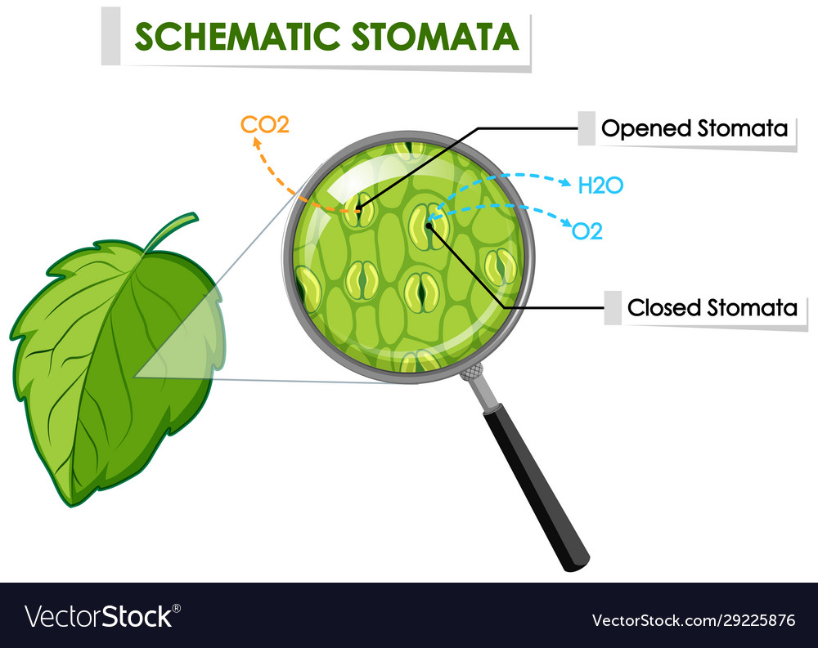

<https://www.vectorstock.com/royalty-free-vector/diagram-showing-schematic-stomata-on-leaf-vector-29225876>

Note:-Create a similar image

### **Electron Transport Chain and ATP Synthesis**

Photosystems are protein complexes found in chloroplasts that catch the light. They help plants in capturing the light energy required for photosynthesis.

Photosystem II works first and absorbs sunlight, and at the same time, it splits water to release oxygen in the air. The energized electrons are transferred through a chain of proteins, where they make energy in the form of ATP.

Now, Photosystem I absorbs more light and helps in re-energizing the electrons to make NADPH, which is another energy molecule. Both these photosystems work together to carry out the reactions of photosynthesis.

Here is a simplified flowchart explaining the electron transport chain and ATP synthesis in photosynthesis-

[Photosystem II] → Excited Electrons → [Electron Transport Chain] → Proton Pumping → [ATP Synthase] → ATP Production → [Photosystem I]

**Quick Check: Which photosystem is responsible for splitting water and releasing oxygen?**

**a) Photosystem I**

**b) Photosystem II**

**c) Both Photosystem I and II**

**d) None of the above**

**Answer: Photosystem II is the correct answer.**

**Explanation: Photosystem II absorbs sunlight, it splits water, releases oxygen.**

## **Respiration in Plants**

## Respiration in plants is a process by which plants convert stored energy in the form of glucose into its usable form. It is essential for plant growth and provides energy and helps in overall functioning.

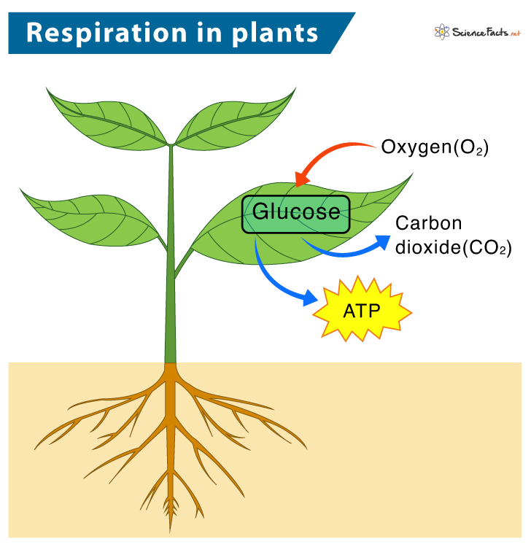

<https://www.sciencefacts.net/respiration-in-plants.html>

Note:-Create a similar image

**Glycolysis**

Glycolysis is the metabolic process that occurs in the cytoplasm, it breaks down glucose into 2 molecules of pyruvate. It involves a series of reactions that results in the production of energy sources such as ATP and NADH as a byproduct.

Let us look at the process of glycolysis in stepwise order.

**Step 1**- The process begins with the phosphorylation of glucose, using two molecules of ATP to convert glucose into fructose-1,6-bisphosphate.

**Step 2**- Fructose-1,6-bisphosphate is then split into glyceraldehyde-3-phosphate (G3P) each containing three carbons.

**Step 3**- G3P is then oxidized, generating NADH and converting ADP into ATP, which produces 1,3-bisphosphoglycerate.

**Step 4**- 1,3-bisphosphoglycerate is then converted into 3-phosphoglycerate, generating another molecule of ATP.

**Step 5**- The conversion of 3-phosphoglycerate into pyruvate results in the production of another ATP molecule.

**Step 6**- In conclusion, glycolysis produces a gain of two ATP molecules, two molecules of NADH, and two molecules of pyruvate.

**Quick Check:** **The process of glycolysis begins with the conversion of fructose-1,6-bisphosphate into glucose. Is it true or false?**

Ans. It is false

Explanation-Glycolysis process begins with the phosphorylation of glucose, not fructose-1,6-bisphosphate.

## **Anaerobic Respiration in Plants**

Anaerobic respiration also called- Fermentation, occurs in the absence of oxygen. It is like an alternate pathway of respiration.

There are two main types of fermentation: alcoholic fermentation and lactic acid fermentation.

* **Alcoholic fermentation** is carried out by yeast and bacteria, which converts glucose into ethanol and carbon dioxide, along with a small amount of energy.



<https://en.wikipedia.org/wiki/Ethanol_fermentation>

Note:-Create a similar image

* **Lactic acid fermentation** also occurs in some plant tissues when oxygen is not readily available. In this process, glucose is converted into pyruvate through glycolysis, but instead of being converted into ethanol, it gets converted into lactic acid.

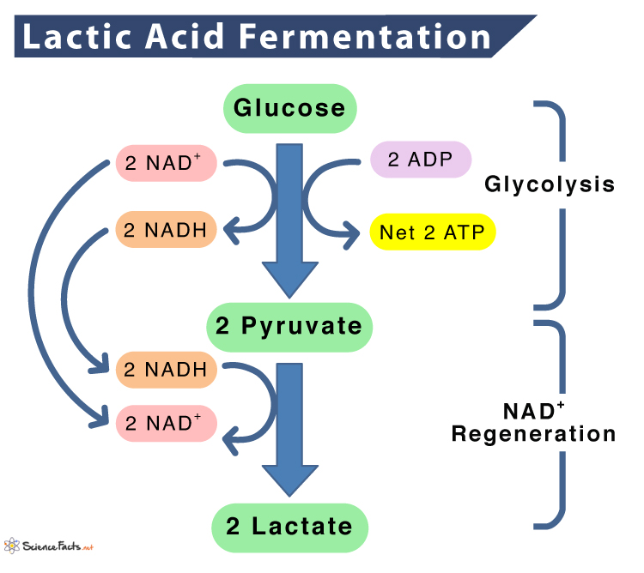

[**https://www.sciencefacts.net/lactic-acid-fermentation.html**](https://www.sciencefacts.net/lactic-acid-fermentation.html)

Note:-Create a similar image

Both these processes in plants are helpful in generating energy in the absence of oxygen.

**Quick Check: In plant tissues, when oxygen is not readily available, which process converts glucose into a different compound?**

1. Photosynthesis b) Aerobic respiration c) Ethanol fermentation d) Lactic acid fermentation

Ans. d) Lactic acid fermentation

Explanation- lactic acid fermentation takes place in the absence of oxygen.

### **Carbohydrate Metabolism**

Carbohydrate metabolism is an essential process in plants that involves the breakdown of carbohydrates which is the synthesized and later utilized for energy and other essential functions.

Carbohydrates, such as glucose and sucrose, serve as the primary source of energy in plants.

Starch synthesis in plants occurs through a series of enzymatic steps-

**Starch Synthesis**

a. Glucose-1-phosphate is converted to ADP-glucose with the help of an enzyme ADP-glucose pyrophosphorylase (AGPase).

b. ADP-glucose acts as the substrate for starch synthesis.

c. The enzyme Starch synthase catalyzes the transfer of glucose molecules from ADP-glucose to the growing starch chain, resulting in the formation of amylose and amylopectin.

d. The branching enzyme (starch branching enzyme or SBE) introduces branch points into the starch chain by transferring segments of glucose to form amylopectin.



<https://www.researchgate.net/figure/Diagram-of-starch-biosynthesis-pathway_fig3_357401789>

Note:-Create a similar image

**Starch Degradation**

a. The process starts with the action of the enzyme α-amylase, which breaks down the internal α-1,4-glycosidic bonds in amylose and amylopectin, releasing smaller fragments called oligosaccharides.

b. Oligosaccharides are then broken down into glucose by the action of enzymes like β-amylase and limit dextrinase.

c. Glucose liberated during starch degradation is utilized as an energy source or can be stored as soluble sugars.

**Quick check: Glucose-1-phosphate is converted to ADP-glucose with the help of an enzyme called Starch synthase. Is It true or false?**

**Answer: It is false.**

**Explanation-** **ADP-glucose is formed from glucose-1-phosphate with the help of ADP-glucose pyrophosphorylase, not Starch synthase.**

### **Sucrose Metabolism and Transport**

Sucrose metabolism involves the breakdown of sucrose.

Sucrose is synthesized and transported through the phloem and can be hydrolyzed in tissues to provide energy or can be stored in the form of starch.

Sucrose metabolism is explained in the following steps–

**Sucrose synthesis**: Glucose and fructose molecules are combined with the enzyme called -sucrose synthase, which results in the formation of sucrose.

⬇️

**Sucrose breakdown**: In sink tissues, such as fruits or roots, sucrose is hydrolyzed by the enzyme invertase or sucrase into glucose and fructose. ⬇️

**Sucrose transpor**t: Sucrose is loaded into the phloem sieve tubes from leaves through active transport mechanisms which utilize sucrose transporters.

⬇️

**Sucrose unloading**: In sink tissues, sucrose is unloaded from the phloem into surrounding cells for utilization and for storage.

⬇️

**Sucrose utilization**: Glucose and fructose produced from sucrose breakdown are used as energy sources or gets converted into other molecules for metabolic processes.

**Quick Check: Sucrose is loaded into the phloem sieve tubes from leaves through passive transport mechanisms. Is it true or false?**

### **Answer: It is false.**

**Explanation-Sucrose is loaded via an active transport mechanism, not passive. Active transport requires energy.**

### **Plant Hormones**

Plant hormones, also called phytohormones, are naturally occurring chemical messengers that regulate many physiological processes in plants. They play pivotal functions in plant growth, development, and responses to environmental stimuli.

Here are the types of plant hormones and their roles in growth and development:

1. **Auxins**

* Helps in cell elongation and tropisms (e.g., phototropism and gravitropism).
* Promote apical growth and inhibit lateral bud growth.
* Stimulate root differentiation and development.
* Contribute in fruit development and prevent fruit drop.

1. **Cytokinins**

* Promotes division of cells
* Delay leaf senescence.
* Promote lateral bud growth

1. **Gibberellins**

* Promotes cell elongation
* Promote seed germination
* Enhances growth of fruits.

1. **Abscisic Acid (ABA)**

* Inhibit seed germination
* promote seed dormancy.
* Induce stomatal closure under water stress.
* Regulate environmental response to stressors such as drought, salinity.

**Quick Check: Which of the following is a function of cytokinins in plants?**

**a) Promoting root growth b) Enhancing leaf photosynthesis c) Inhibiting cell division d) Delaying leaf senescence and promoting lateral bud growth**

**Answer: Delaying leaf senescence and promoting lateral bud growth**

**Explanation: The main function of cytokinis in plants is to delay leaf senescence and to promote the lateral bud growth.**



[**https://classnotes123.com/what-are-plant-hormones-class-10/**](https://classnotes123.com/what-are-plant-hormones-class-10/)

Note:-Create a similar image

**Wrap-Up**

**Plant Biochemistry**

**Carbohydrate Metabolism**

Starch Synthesis and Degradation

Sucrose Metabolism anTransport

**Respiration**

Glycolysis

Conversion of glucose to pyruvate

ATP production and NADH generation

Anaerobic Respiration

Types of fermentation (alcoholic and lactic acid fermentation)

**Plant Cell Metabolism**

**Photosynthesis**

Leaf structure and arrangement

Photosystems (Photosystem I and Photosystem II)

Electron transport chain and ATP synthesis

**Plant Hormones**

Types of Plant hormones

Roles of plant hormones in growth and development

**Lesson Review**

* Plant biochemistry is the study that involves studying chemical processes and molecular mechanisms in plants.
* Photosynthesis is a process by which plants convert sunlight, carbon dioxide, and water into a form of sugar- glucose, and oxygen.
* Glycolysis is the metabolic process that occurs in the cytoplasm, it breaks down glucose into 2 molecules of pyruvate.
* Carbohydrate metabolism is an essential process in plants that involves the breakdown of carbohydrates
* Alcoholic fermentation converts glucose into ethanol and carbon dioxide, along with a small amount of energy.
* Lactic acid fermentation involves conversion of glucose into pyruvate through glycolysis, it gets converted into lactic acid.
* Plant hormones, also called phytohormones, play pivotal role in plant growth, development, and responses to environmental stimuli.

**Lesson Vocabulary Words**

**Algae:** Photosynthetic organisms, can be unicellular or multicellular found in variety of habitats.

**Bacteria**: Single cells, prokaryotic organisms present in diverse environments.

**Enzyme:** Act as a catalyst which boosts chemical reactions.

**Glucose:** Simple and essential sugar for growth and development.

**Metabolism:** Sum of all bodily reactions, involving energy transformation and synthesis.

**Nucleus:** Main control centre of a cell which contains genetic material in the form of DNA.

**Oxidation:** Chemical process which involves increase in oxidative state.

**Starch:** Complex carbohydrate which is used as a storage form in plants.

**Stomata:** Microscopic tiny pores on the leaf surface which regulates gaseous exchange.

**Project**

Analyse the relationship between light and plant biochemistry.

Investigate the role of photosystems, pigments, and electron transport chains in harnessing light energy for ATP synthesis during photosynthesis.

**Instructions**

* Analyse the relationship between light and plant biochemistry.
* Investigate the role of photosystems, pigments, and electron transport chains in ATP synthesis during photosynthesis.
* Provide a clear introduction, conduct thorough research, and engage in a detailed discussion.

**Introduction**

Start with a concise introduction that sets the context for the topic. Briefly explain the significance of photosynthesis. Highlight the main role of light in driving plant biochemistry, also introduce the key components to be discussed: photosystems, pigments, and electron transport chains.

**Research**

Research and describe the two types of photosystems, PSII and PSI

Explore the major pigments involved in photosynthesis, particularly chlorophyll a and chlorophyll b.

Investigate the electron transport chains associated with PSII and PSI.

**Discussion:**

* Explain the interplay between photosystems, pigments, and electron transport chains in utilizing light energy for ATP synthesis.
* Highlight the importance of light as the primary source of energy and its role in activating the photosystems.
* Discuss the specific functions of pigments, such as chlorophyll, in absorbing different wavelengths of light and transferring that energy to the reaction centers of photosystems.
* Elaborate on the stepwise flow of electrons through the electron transport chains, resulting in the generation of a proton gradient and ATP production via chemiosmosis.
* Emphasize the vital role of ATP in supporting various biochemical processes in plants and their overall growth and development.

**Forum**

Discuss the processes of sucrose metabolism and starch metabolism in plants. How are sucrose and starch synthesized, transported, and utilized in plant metabolism? Explain the key enzymes involved in the process and the role of active transport in sucrose transport.

**Sample feedback**

Sucrose metabolism in plants involves the synthesis, transport, and utilization of sucrose. Sucrose is synthesized by combining glucose and fructose by the action of an enzyme sucrose synthase.

It is then loaded into phloem sieve tubes through active transport mechanisms. In sink tissues, sucrose can be hydrolyzed into glucose and fructose by enzymes like invertase or sucrase for energy production or storage.

Starch metabolism involves starch synthesis and degradation. Starch is synthesized through the conversion of glucose-1-phosphate to ADP-glucose by the enzyme ADP-glucose pyrophosphorylase. Starch synthase and branching enzyme play roles in the transfer and branching of glucose molecules to form amylose and amylopectin. Starch is degraded by enzymes like α-amylase, β-amylase, and limit dextrinase, releasing glucose for energy use or storage.

Active transport is important in loading sucrose into phloem sieve tubes, which allows long distance transport of food in plants.

**Assessments**

**DOK 1**

Q1. Plant biochemistry involves the study of?

A) Cellular respiration and energy production

B) Photosynthesis and carbon fixation

C) Metabolism and nutrient uptake

D) All of the above

Ans: D) All of the above

Explanation: Plant biochemistry involves the study of cellular components, respiration, process of photosynthesis, plant metabolism and nutrient uptake required.

Q2. Which structure is responsible for storing water in plant cells?

A) Cell wall

B) Nuclei

C) Mitochondria

D) Central vacuole

Ans: D) Central vacuole

Explanation: Central vacuole is a single large cavity that stores water.

Q3. What are the tiny microscopic openings on the surface of a leaf called?

A) Epidermis

B) Stomata

C) Exodermis

D) Xylem

Ans: B) Stomata

Explanation: Stomata are tiny pores on the leaf surface that helps in gaseous exchange.

Q4.Which of the following is the primary product of photosynthesis?

A) Carbon dioxide

B) Oxygen

C) Glucose

D) Molecules of water

Ans: C) Glucose

Explanation: Photosynthesis results in the formation of glucose as an energy source for plants.

Q5. Which is responsible for splitting water and releasing oxygen during photosynthesis?

A) Photosystem I

B) Photosystem II

C) ATP synthase

D) Amylase reductase

Ans: B) Photosystem II

Explanation: Photosystem I is responsible for splitting water and releasing oxygen during photosynthesis

Q6. Glycolysis results in the formation of?

A) Glucose

B) Pyruvate

C) ATP

D) Oxygen

Ans: B) Pyruvate

Explanation: Glycolysis is the main pathway that breaks down glucose into pyruvate.

Q7.Which enzyme transfers glucose molecules from ADP-glucose to the growing starch chain during starch synthesis?

A) ADP-glucose pyrophosphorylase (AGPase)

B) Starch synthase

C) Starch branching enzyme (SBE)

D) Glucose-1-phosphate

Ans: B) Starch synthase

Explanation: Starch synthase transfers glucose molecules from ADP-glucose to the growing starch chain during the process of starch synthesis.

Q8. Which is a byprouct during lactic acid fermentation in plants?

A) Ethanol

B) Glucose

C) Carbon dioxide

D) Lactic acid

Ans: D) Lactic acid

Explanation: Lactic acid fermentation occurs in the absence of oxygen and results in the formation of lactic acid.

Q9. Which photosystem is responsible for re-energizing electrons to produce NADPH in photosynthesis?

A) Photosystem I

B) Photosystem II

C) Electron Transport Chain

D) ATP Synthase

Ans: A) Photosystem I

Explanation: Photosystem I re-energizes electrons to produce NADPH in photosynthesis.

Q10. Which type of fermentation is carried out by yeast and bacteria, which converts glucose into ethanol ?

A) Alcoholic fermentation

B) Lactic acid fermentation

C) Aerobic respiration

D) Glycolysis

Ans: A) Alcoholic fermentation

Explanation: Alcoholic fermentation is carried out by yeast and bacteria, when oxygen is supply is not there.

**DOK 2**

Q11.What are the main functions of Abscisic Acid (ABA) in plants?

A) Abscisic Acid helps in Stimulating seed germination

B) Abscisic Acid helps in Enhancing seed dormancy

C) Abscisic Acid helps in Promoting stomatal opening

D) Abscisic Acid helps in Increasing plant growth in drought like conditions

Ans: B) Enhancing seed dormancy

Explanation: Abscisic acid in plants enhances the seed dormancy which further inhibits seed germination.

Q12. Which of the statements best describes the importance of photosynthesis?

A) Photosynthesis is the main source of energy for most ecosystems.

B) Photosynthesis plays a minor role in plant growth and metabolism.

C) Photosynthesis is carried out in aquatic organisms.

D) Photosynthesis is responsible for the production of oxygen in the atmosphere.

Ans: A) Photosynthesis is the main source of energy for most ecosystems.

Explanation: Photosynthesis is crucial as it provides the primary energy needed for the survival of plants.

Q13. Which of the following statements is true with respect to photosystems involved in photosynthesis?

A) Photosystem I absorbs sunlight and splits water to release oxygen.

B) Photosystem II absorbs sunlight and helps in re-energizing electrons to produce NADPH.

C) Photosystem II absorbs sunlight and produces ATP.

D) Photosystem I absorbs sunlight and produces ATP.

Ans: C) Photosystem II absorbs sunlight and produces ATP.

Explanation: Photosystem II absorbs sunlight and is responsible for producing energy in the form of ATP during the process of photosynthesis.

Q14.Which cellular structures are essential for the effective functioning of plant cells?

A) Thick cell wall, small vacuole, and chloroplasts.

B) Thin cell wall, large vacuole, and mitochondria.

C) Thick cell wall, large vacuole, and chloroplasts.

D) Thin cell wall, mitochondria, and small vacuole

Ans: C) Thick cell wall, large vacuole, and chloroplasts.

Explanation: Plants need a thick cell wall that maintains a definite shape and structure, a large vacoule, and chloroplasts for carrying out effective functions.

Q15. How is sucrose transported and utilized in plants?

A) Sucrose is synthesized from glucose by the enzyme invertase.

B) Sucrose is unloaded from the phloem into sink tissues for energy utilization.

C) Sucrose is broken down into glucose and fructose by the enzyme sucrose synthase.

D) Sucrose is transported into the sieve tubes of phloem through active transport mechanisms.

Ans: B) Sucrose is unloaded from the phloem into sink tissues for energy utilization.

Explanation: Sucrose is transported via the phloem and unloaded into sink tissues for utilization as an energy source.

Q16. What is the main function of stomata in leaf structure and arrangement?

A) Stomata in leaf structure and arrangement primarily serve the function of protecting against pathogens.

B) Stomata in leaf structure and arrangement primarily serve the function of absorbing water and minerals.

C) Stomata in leaf structure and arrangement primarily serve the function of regulating gas exchange.

D) Stomata in leaf structure and arrangement do not have the main function of storing nutrients.

Ans: C) Stomata in leaf structure and arrangement primarily serve the function of regulating gas exchange.

Explanation: The main function of stomata is to regulate the amount of gaseous exchange which aids in the process of photosynthesis and respiration.

Q17. In lactic acid fermentation, during the absence of oxygen, glucose is converted into which compound?

A) Pyruvate through glycolysis, and then into lactic acid

B) Ethanol through glycolysis, and then into lactic acid

C) Carbon dioxide through glycolysis, and then into lactic acid

D) Pyruvate through Krebs cycle, and then into lactic acid

Ans: A) Pyruvate through glycolysis, and then into lactic acid

Explanation: In the absence of enough oxygen, plants undergo lactic acid fermentation in which glucose is converted into pyruvate through the process of glycolysis.

Q18. Which of the following cells in the leaf contain chloroplasts responsible for photosynthesis?

A) The epidermal cells of the leaf

B) The stomatal cells on the lower surface of the leaf

C) The mesophyll cells of the leaf

D) The vascular cells within the leaf

Ans: C) The mesophyll cells of the leaf

Explanation: Chloroplasts is present in the mesophyll cells of the leaf which carries out the function of photosynthesis.

Q19.Assertion: Photosystem II is responsible for splitting water and generating ATP in photosynthesis.

Reasoning: Photosystem II absorbs sunlight and energizes electrons, which are transferred through an electron transport chain, resulting in ATP production.

A) Both the assertion and reasoning are correct, and the reasoning correctly explains the assertion.

B) Both the assertion and reasoning are correct, but the reasoning does not correctly explain the assertion.

C) The assertion is correct, but the reasoning is incorrect.

D) The assertion is incorrect, but the reasoning is correct.

Ans: A) Both the assertion and reasoning are correct, and the reasoning correctly explains the assertion.

Explanation: Both the assertion and reason are correct as Photosystem II absorbs sunlight, which then energizes electrons, and generates ATP through an electron transport chain.

Q20.Which of the following statements about photosynthesis is correct?

A) Photosynthesis is a biochemical process that converts glucose and oxygen into sunlight, carbon dioxide, and water.

B) Photosynthesis is a process by which plants convert sunlight, carbon dioxide, and water into glucose and oxygen.

C) Photosynthesis is a process that occurs only in animals and is responsible for converting glucose into sunlight and water.

D) Photosynthesis is a process in which plants convert sunlight, water, and oxygen into glucose and carbon dioxide.

Ans: B) Photosynthesis is a process by which plants convert sunlight, carbon dioxide, and water into glucose and oxygen.

Explanation: Photosynthesis is the process by which plants converts sunglight, into water and glucose required for survival.

**DOK 3**

**Q21.**A group of researchers were studying the effects of plant hormones on the growth and development of a specific crop. During their investigation, they focused on auxins, one of the key plant hormones.

Which of the following is the role of auxins in plant growth and development?

a) Inhibiting root differentiation and development

b) Promoting lateral bud growth

c) Preventing fruit development

d) Stimulating cell elongation and tropisms

Ans: d) Stimulating cell elongation and tropisms

Explanation: Auxin’s hormone’s main function is to promote cell elongation, augmenting growth and development.

Q22. A group of researchers conducted an experiment to study the effect of a specific treatment on carbohydrate metabolism in plants. They observed a significant increase in the levels of glucose-1-phosphate in the treated plants. Based on this finding, they concluded that:

a) Starch synthesis would be enhanced.

b) Starch synthesis would be inhibited.

c) The levels of sucrose would decrease.

d) The levels of sucrose would increase.

Ans: a) Starch synthesis would be enhanced.

Explanation: Glucose-1-phosphate is formed as an intermediate product in starch synthesis, so an increase in its levels shows an enhancement of starch synthesis in plants.

Q23. Read the following Assertion (A) and Reason (R ) and choose the correct option.

Assertion: Stomata play a vital role in photosynthesis in plants.

Reason: Stomata enable the entry of carbon dioxide (required for photosynthesis) and the release of oxygen and water vapor in the environment.

a) Both the assertion and reason are true, and the reason is the correct explanation of the assertion.

b) Both the assertion and reason are true, but the reason is NOT the correct explanation of the assertion.

c) The assertion is true, but the reason is false.

d) The assertion is false, but the reason is true.

Ans: a) Both the assertion and reason are true, and the reason is the correct explanation of the assertion.

Explanation: Both the assertion and reason is true, and the reason is the correct explanation of the assertion, because stomata plays an important role in entry and exit of gases which happens during photosynthesis.

Q24. A group of researchers is studying a plant species found in a heavily polluted area. They are interested in understanding how the plant's cellular structure may contribute to its ability to withstand environmental stressors.

Which cellular component of the plant is likely to play a crucial role in protecting the plant from harmful pollutants and maintaining cellular integrity?

a) Cytoplasm

b) Cell membrane

c) Cell wall

d) Nucleus

Ans: c) Cell wall

Explanation: The cell wall protects the cell structure and gives it a definite shape, and maintains integrity.

Q25. A group of researchers are studying the effects of different light conditions on the growth of a specific plant species.

Which component of the plant cell, would you expect to observe the most significant changes when studying the impact of light conditions on plant growth and energy production?

a) Nucleus

b) Mitochondria

c) Cell membrane

d) Chloroplasts

Ans: d) Chloroplasts

Explanation: Chloroplasts are responsible for photosynthesis which then converts light energy into chemical energy for growth and development.

Q26. A group of researchers is conducting an experiment to study about the effects of a specific environmental factor on photosynthesis in a plant.

The researchers observed a decrease in the production of oxygen during the experiment, which photosystem is most likely to be affected by the environmental factor?

a) Photosystem II

b) Photosystem I

c) Both Photosystem II and Photosystem I equally

d) Neither Photosystem II nor Photosystem I

Ans: a) Photosystem II

Explanation: Photosystem II is responsible for generating oxygen during the light-dependent reactions in plant species.

Q27.A group of researchers is investigating the effects of a specific compound on the metabolic processes of a cell.

If the researchers observe a decrease in the production of ATP and NADH in the cell, which metabolic process is most likely to be affected by the compound?

a) Electron transport chain

b) Krebs cycle (Citric Acid Cycle)

c) Glycolysis

d) Photosynthesis

Ans: b) Krebs cycle (Citric Acid Cycle)

Explanation: Kreb cycle is responsible for generating ATP and NADPH during various plant metabolic pathways. A decrease in the amount of ATP production shows an affliction to kreb cycle.

Q28: A group of scientists were conducting an experiment to investigate the factors influencing starch synthesis in plants. They decide to alter the levels of ADP-glucose in the plants and observe the effects on starch production.

If the researchers decrease the activity of ADP-glucose pyrophosphorylase (AGPase) in the plants, what impact would this likely have on starch synthesis?

a) Starch synthesis would be enhanced.

b) Starch synthesis would be inhibited.

c) Amylose formation would increase.

d) Amylopectin branching would decrease.

Ans: b) Starch synthesis would be inhibited.

Explanation: ADP-glucose pyrophosphorylase (AGPase) enzyme is involved in the first step of starch synthesis, if its activity gets decreased, it will directly affect the process of starch synthesis.

Q29. A gardener is concerned that fruits of his farm are not developing and having excessive fruit drop. He wants to investigate the potential role of a specific plant hormone in addressing these issues.

Which plant hormone plays an important role in fruit development and preventing fruit drop?

a) Auxins

b) Gibberellins

c) Cytokinins

d) Abscisic Acid (ABA)

Ans: a) Auxins

Explanation: Auxin hormone plays an important role in fruit development; he should make use of it.

Q30. A group of researchers is studying the transport and utilization of sucrose in a specific crop plant. They are particularly interested in understanding the fate of sucrose once it is unloaded from the phloem into the sink tissues.

Once sucrose is unloaded from the phloem into the sink tissues, what is the likely fate of the glucose and fructose produced from sucrose breakdown?

a) They are converted into sucrose for re-transport

b) They are converted into starch for storage.

c) They are transported back to the leaves.

d) They are used as energy sources.

Ans: d) They are used as energy sources.

Explanation: Once sucrose is unloaded, glucose and fructose molecules are derived from it, which serve as energy storage molecules for further use.

DOK 4

**Open Ended Questions**

31. What do you mean by plant hormones? Give some examples and their functions.

Sample answer: Plant hormones are natural chemical messengers that regulate plant growth and development. Examples include auxins, cytokinins, gibberellins, and abscisic acid. They control processes like cell elongation, division, and response to environmental stimuli.

32. What do you mean by Glycolysis? Explain the process stepwise.

Sample answer: Glycolysis is the metabolic process that involves breaking down molecules of glucose into pyruvate. It involves a series of reactions that produce energy in the form of ATP and NADH.

33. How is starch synthesized in plants, and what are the main enzymes involved in this process?

Sample answer: Starch synthesis is done in plants by converting glucose-1-phosphate to ADP-glucose, which is then used by starch synthase and branching enzyme to form amylose and amylopectin as a product.

34. Describe the process of electron transport chain and ATP synthesis in photosynthesis, including the roles of photosystem II, photosystem I, and ATP synthase.

Sample answer: In photosynthesis, photosystem II works first by absorbing light and splits water to release oxygen. Energized electrons then passes through the electron transport chain, pumping protons and creating ATP. Photosystem I then re-energizes electrons, forming NADPH.

35. What does a plant cell consists of? Discuss the functions of organelles?

Sample answer: A plant cell consists of an outer cell wall, cell membrane, cytoplasm, nucleus, chloroplasts, mitochondria, vacuoles, and endoplasmic reticulum.

Organelles perform specific functions like energy production (mitochondria), photosynthesis (chloroplasts), and storage (vacuoles).

**References**

<https://www.acs.edu.au/courses/biochemistry-i-plants-200.aspx>

<https://www.embibe.com/questions/Draw-a-typical-plant-cell-and-label-the-following-parts--%28a%29-Cell-wall-%28b%29-Nucleus-%28c%29-Chloroplast-%28d%29-Vacuole./EM7120695>

<https://www.khanacademy.org/science/ap-biology/cellular-energetics/photosynthesis/a/intro-to-photosynthesis>

<https://www.vectorstock.com/royalty-free-vector/diagram-showing-schematic-stomata-on-leaf-vector-29225876>

<https://www.sciencefacts.net/respiration-in-plants.html>

<https://en.wikipedia.org/wiki/Ethanol_fermentation>

[https://www.sciencefacts.net/lactic-acid-fermentation.htm](https://www.sciencefacts.net/lactic-acid-fermentation.html)

<https://www.researchgate.net/figure/Diagram-of-starch-biosynthesis-pathway_fig3_357401789>